Kien Vu

Question 1: **Euclidean Distance**

1. 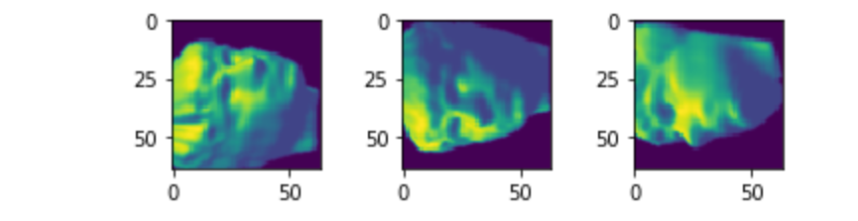Image 0, and (Image 1, Image3) are not connected to each other according to adjacency matrix

b) Image 0, and image 2, 4,9 belong to same group ( representing small distance in adjacency matrix). They are all facing left

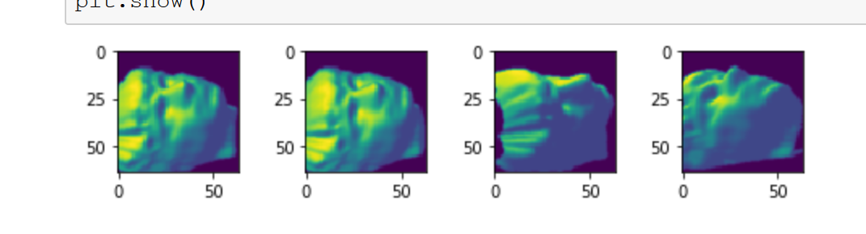

C) 20 images similar to image 0 after performing ISOMAP and calculating Euclidean distance of 2 principal components. They are visually similar which all faces are facing left.

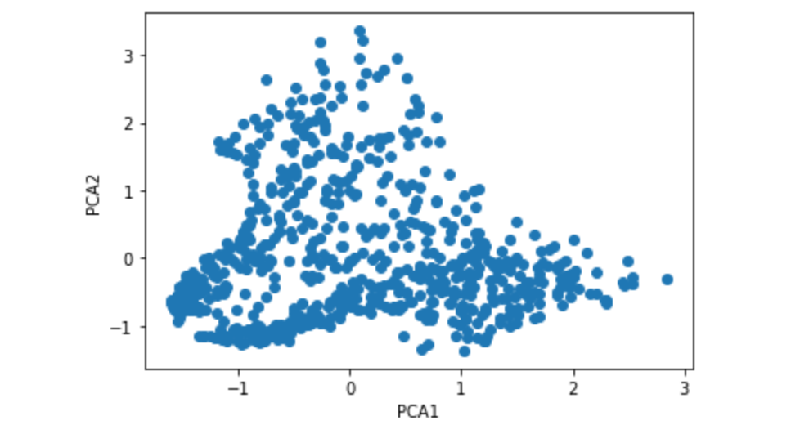

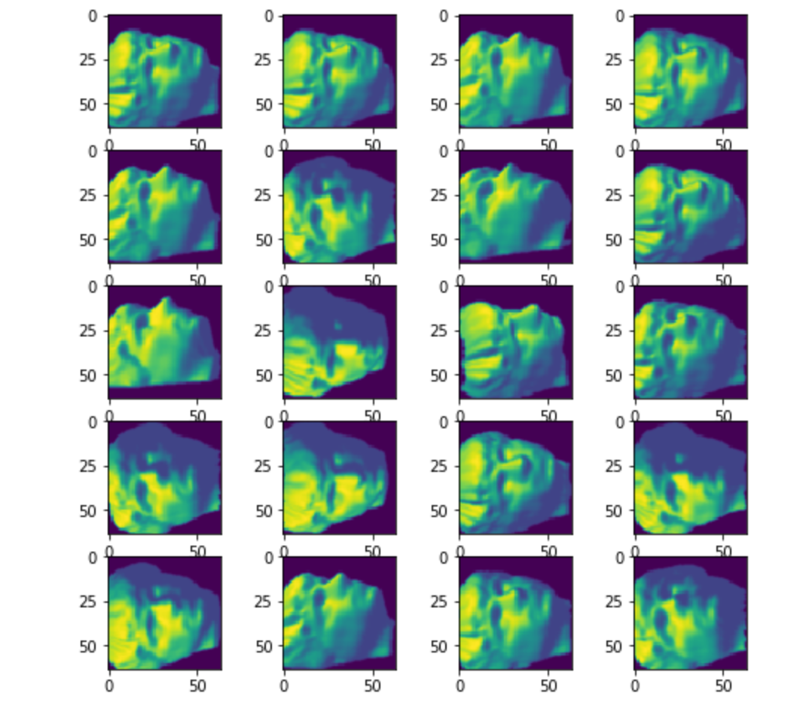

**Manhattan Distance**

**I see substantial difference while performing ISOMAP with “Euclidean distance” vs “Manhattan distance”**

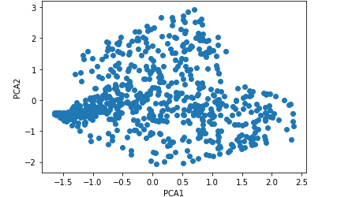

**Top 20 images similar to Image 0 based on embedding ISOMAP using “ Manhattan Distance “ and Manhattan distance as measured of similarity**

